“Pursuit of Happiness:” Mapping Undergraduate Social Support Systems at The Ohio State University

Kaitlyn Davis, Amanda Konet, Dr. Yvette Shen, Meghana Yechuri, Shasha Yu

**Abstract**—Many undergraduate students at Ohio State struggle with stress, anxiety, depression and other mental health issues but are unaware of the multitude of resources available to them both on campus and in their personal social networks. Such social support systems are essential for students to avoid feelings of isolation that may amplify said mental health issues. This project aims to create visibility to the on-campus services available to undergraduate students via an interactive web application. This web application allows students to create a stress portrait that will identify a personalized social support network consisting of on and off-campus resources that may be most beneficial to them.

Introduction

The Ohio State University is a large campus with a wealth of resources available to students. Such resources include, but are not limited to, Counseling and Consultation Services, Wellness Coaching, the Dennis Learning Center, and Financial Services. Though Ohio State does their best to market these resources to their future and current students, many remain unaware of their existence and all of the services that these resources provide. Additionally, in times of stress people often lose sight of their own social support systems, which causes them to experience feelings of isolation. Thus, it is important to remind students of personal connections they have that fulfill different roles, such as emotional, appraisal, instrumental, and informative support. In order to tackle these issues, Dr. Yvette Shen conceptualized an interactive web application that will assist distressed students in locating the right campus resources for them. This simple and user-friendly tool will allow students to select their stressors and fill in their personal social support network. This information will then be used to create a “stress portrait” — a compilation of the chosen triggers for a specific student. These chosen triggers are then mapped to specific on-campus resources that have services aimed at providing support for said triggers. This interactive web application will display one’s personalized stress triggers along with links to the resources to deal with those said issues. Ideally, this tool makes the process of finding a solution much easier. This interactive web application will also incorporate fourteen “positive psychological strategies” such as gratitude journaling, goal writing, and motivational quotes to promote positive thinking and behavior.

# Research Questions

Through building this personalized social support network, there are a few research questions we may be able to answer. First, how can we map specific stressors to more general stress categories so that we can provide the most accurate and useful resources to students? For example, there may not be an entire resource dedicated to helping students who are struggling with deadlines, but there may be a more general academic services resource. Broadening the stress category will help us more easily identify a resource on campus that students can then be directed to. Additionally, how can we display social support networks in a way that is informative, inviting and user-friendly? If the web application is difficult to navigate or students do not feel comfortable using it, then the purpose of the project is not fulfilled and the design must be reconfigured. The design must be user-centric so that students are easily able to navigate the application and ultimately contact the resource centers suggested. Lastly, we must decide if it will be useful to students if the application saves the information so they may view it later. Perhaps students may only want to view this information once, or perhaps they would like to revisit it if their stress resurfaces.

* Kaitlyn Davis. Email: davis.@osu.edu.
* Amanda Konet. Email: konet.5@osu.edu.
* Dr. Yvette Shen. Email: shen.1049@osu.edu.
* Meghana Yechuri. Email: yechuri.1@osu.edu.
* Sasha Yu. Email: yu.2116@osu.edu.

# Design Goals

The goal of this project is to develop a multi-layered interactive web application. Potentially, students will be able to log in to the application with their own username and password. This will allow them the ability to log back in and re-visit their results. As previously mentioned, students will select their personal stressors from a list. For example, a student may indicate that they feel the following stressors: academics, work-study balance, social issues, and language and cultural differences. The stressors will be displayed in abstract polygon shapes (see Figure 1), and a combination of hue and intensity may be used to encode the broader category of stress a specific stressor falls under, or to perhaps encode an emotion. In addition to stressors, students will be prompted to enter the people they feel fulfill different support roles in their lives such as emotional, appraisal, informational and instrumental support.

Then, a “stress portrait” will be built that showcases their stressors, which will be linked to an on-campus service that provides support for that particular stressor. A social support network will also be created to show the personal connection(s) each user has access to during times of difficulty. This social support network design is currently under progress, though an initial design idea by Dr. Jian Chen features a map of campus that displays markers at the locations of suggested resources. The design also looks at encoding general category of stress with hue and intensity. Lastly, positive psychology strategies will also be included. The placement of these strategies is currently undecided. If there is an option for users to log-in, the positive psychology strategies could pop up upon login. If not, the strategies could be placed on the same page as the stress portrait.

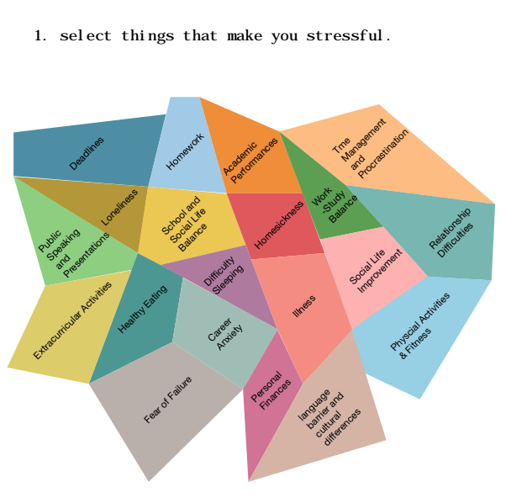

Figure 1: Stress Portrait (Prior to a student’s personal selection)

# Implementation

In order to create an interactive web application, the traditional web page building languages, HTML, CSS, and Javascript, should be used. The stress portrait and social support network designs will most likely be implemented using D3. We may look into the possibility of incorporating Raw Graph into the web application, though D3 seems to be the most equipped tool for this task.

## Tasks and Metrics

One way to measure how user-friendly the application is would be to email students who sign up for the application and ask them to complete a brief survey. This survey will perhaps ask if they found the app easy to navigate, useful, or will use suggested services now or in the future. We may also explore testing the application out on our personal friends here at Ohio State.

# Potential Impact

One potential impact of the Pursuit of Happiness project is further exploration into the balance between the usability of the design and how visually pleasing it is to the user. The end goal of this project is a product that allows students to connect with necessary on-campus resources. However, the design should be visually pleasing and easy to read.

The social impact of this design is perhaps the part of this project that will have the most impact. As previously mentioned, many students at Ohio State are unaware of the multitude of resources that are provided to them by the university. This tool will ideally create awareness of these resources and ultimately promote their use, thus positively impacting mental health at Ohio State University.